**.NET MVC: Project Report**

Stephan Moncavage

Grand Canyon University

CST-247: Enterprise Applications III

Michael Pritchard

10 January 2021

GitHub: https://github.com/smoncavage/SchoolWork/tree/master/CST247%20Enterprise%20Applications%203

**CST-247 Activity 1 Report**

Contents

Activity 1 2

Part 1: Tools Installation and Validation 2

Part 2: Introduction to .NET MVC Controllers and Views 4

Part 3: Advanced .NET MVC Models, Controllers, Views 8

# Activity 1

This activity has multiple parts/assignments. All assignments must be completed prior to documentation submission.

## Part 1: Tools Installation and Validation

**Documentation**

All documentation will be submitted at the end of the activity to the learning management system. Ensure documentation of the following:

1. Create a project report using a GCU standard Project Header/Cover Page to include a header, your name, course, assignment name, and date.
2. After creating the default .NET MVC project, run the project, and attach a screenshot of your working application in your project report. Label this Screenshot 1.
   1. Screenshot 1 – Working Base Application

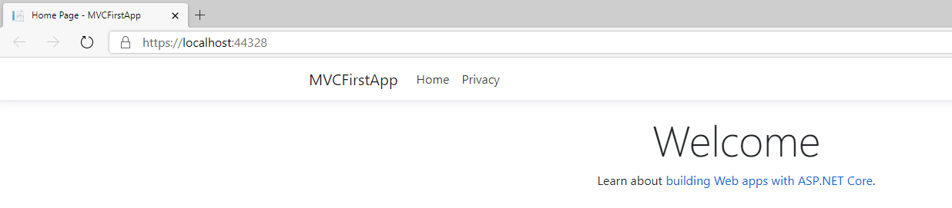

1. After finishing the ASP.NET MVC Tutorials, identify six things you learned and document them in your project report with details and examples. Provide references and citations. <https://www.tutorialspoint.com/asp.net_mvc/index.htm>
   1. ASP.NET MVC is an alternative to ASP.NET Web Forms (ASP.NET MVC Overview, n.d.). This framework is licensed under the Microsoft Public License as well as the Apache 2.0 License for certain parts. There are two distinct lifecycles to ASP.NET MVC, the application lifecycle which refers to the application process begin and end events; as well as the request lifecycle that occurs for each HTTP request that is handled by the application. All routing information is contained within the Global.asax file within the application and is implemented by the RouteConfig class (ASP.NET MVC Routing, n.d.). These route map to URL’s with each controller configured action or each method within the controller. Routes can be customized by adding in custom controllers and views which can then also be connected to the default controllers and views if necessary, warranted, or preferred.

## Part 2: Introduction to .NET MVC Controllers and Views

**Overview**

In this activity, students will create an empty .NET MVC application in Visual Studio and use this project as a basis to learn how to create Controllers and basic Views.

**Documentation**

All documentation will be submitted at the end of the activity to the learning management system. Ensure documentation of the following:

1. Updates to the project report created in Part 1 with all applicable screenshots.
   1. Screenshot 2 - /Test URI

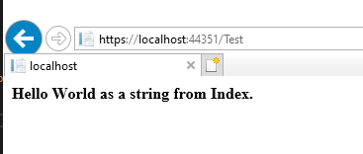

* 1. Screenshot 3 - /Test/Play URI

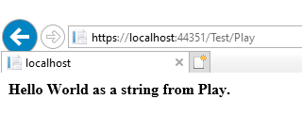

* 1. Screenshot 4 - /TestView URI

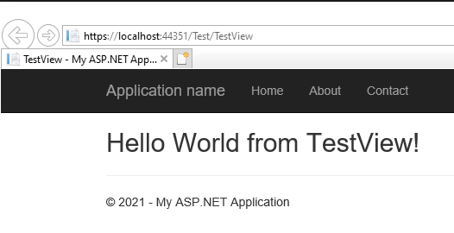

1. After creating the default .NET MVC Project, run the project and attach a screenshot of your working application in your project report. Label this Screenshot 5.
   1. Screenshot 5 – Default MVC Project

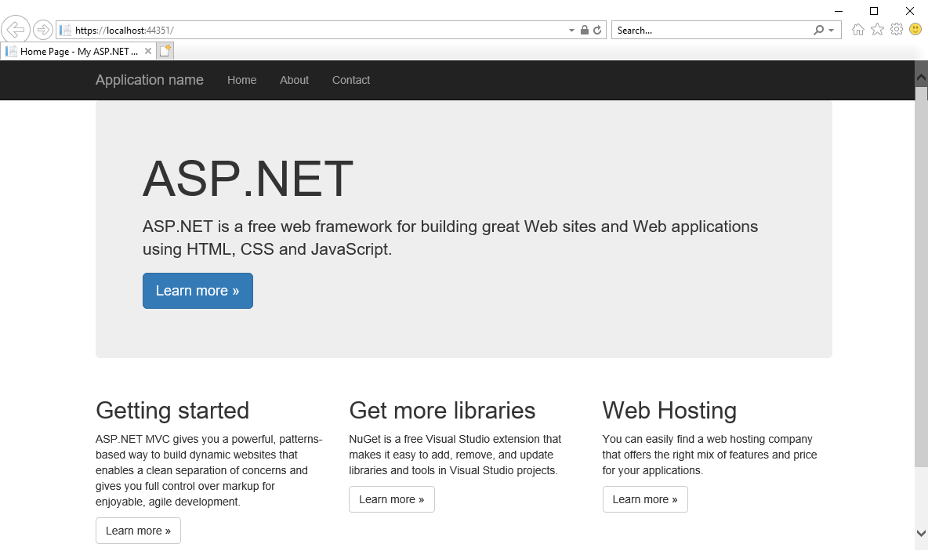

1. After finishing the ASP.NET MVC Tutorials identify six things you learned, and document them in your project report with details and examples. Provide references and citations. <https://www.tutorialspoint.com/asp.net_mvc/index.htm>
   1. ASP.NET MVC – Controllers
   2. ASP.NET MVC – Actions
   3. ASP.NET MVC – Filters
   4. ASP.NET MVC – Selectors
   5. ASP.NET MVC – Views
   6. ASP.NET MVC - Data Model
   7. ASP.NET MVC – Helpers
   8. ASP.NET MVC - Model Binding

## Part 3: Advanced .NET MVC Models, Controllers, Views

**Overview**

In this activity, students will use .NET MVC Routes, Controllers, Models, and Views to build a simple Login Page using a N-Layer Web Application Architecture.

**Documentation**

All documentation will be submitted at the end of the activity to the learning management system. Ensure documentation of the following:

Submit the following to the learning management system:

1. Test your Login View from end to end.
   1. Screenshot 6 – Login Passed

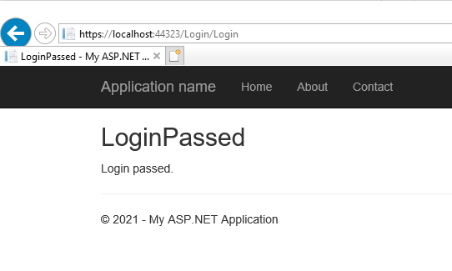

* 1. Screenshot 7 – Login Failed

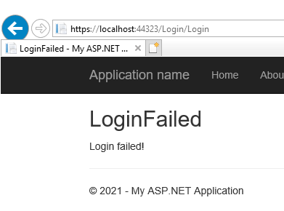

1. Take a screenshot of the login results for a user that exists in the database and a user that does not exist in the database.
   1. Screenshot 8 – Does Exist

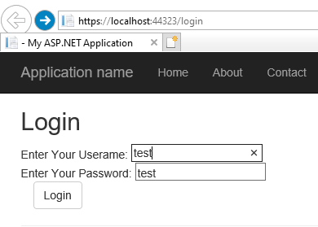

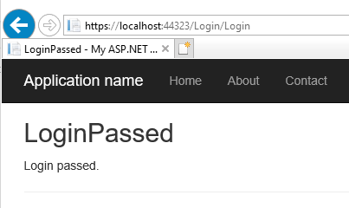

* 1. Screenshot 9 – Does Not Exist

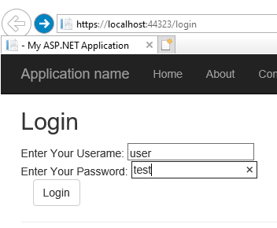

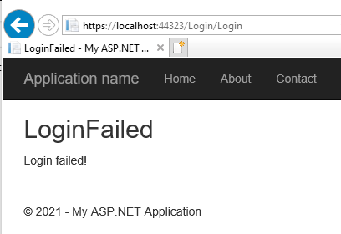

**Reference**

ASP.NET MVC Tutorial. (n.d.). Retrieved January 03, 2021, from https://www.tutorialspoint.com/asp.net_mvc/index.htm

Dotnet-Bot. (n.d.). .NET API browser. Retrieved January 03, 2021, from https://docs.microsoft.com/en-us/dotnet/api/

Friedman, J. (2016, June 07). ADO.NET Tutorial. Retrieved January 03, 2021, from http://csharp-station.com/Tutorial/AdoDotNet

Galloway, J., Wilson, B., Allen, K. S., & Matson, D. (2014). Controllers. In *Professional ASP.NET MVC 5* (pp. 31-48). Indianapolis, IN: John Wiley & Sons.

Galloway, J., Wilson, B., Allen, K. S., & Matson, D. (2014). Getting Started. In *Professional ASP.NET MVC 5* (pp. 1-30). Indianapolis, IN: John Wiley & Sons.

Galloway, J., Wilson, B., Allen, K. S., & Matson, D. (2014). Models. In *Professional ASP.NET MVC 5* (pp. 75-108). Indianapolis, IN: John Wiley & Sons.

Galloway, J., Wilson, B., Allen, K. S., & Matson, D. (2014). Views. In *Professional ASP.NET MVC 5* (pp. 49-74). Indianapolis, IN: John Wiley & Sons.

Matskas, C., & Marsh, K. (2020, December 18). Channel 9 provides videos for developers, delivered by the people who work behind the scenes at Microsoft. Retrieved January 03, 2021, from https://channel9.msdn.com/On-NET/What-is-MSAL--MicrosoftIdentityWeb

Shojaee, H. (2012, February 20). Intro to Scrum in Under 10 Minutes. Retrieved January 03, 2021, from https://www.youtube.com/watch?v=XU0llRltyFM

SQL - Create Tables. (n.d.). Retrieved January 03, 2021, from https://www.tutorialspoint.com/t_sql/t_sql_create_tables.htm

Stein, S., Schonning, N., Coulter, D., Sherer, T., & Warren, G. (2017, March 30). Code examples - ADO.NET. Retrieved January 03, 2021, from https://docs.microsoft.com/en-us/dotnet/framework/data/adonet/ado-net-code-examples

Stein, S., Schonning, N., Sherer, T., & Wenzel, M. (2017, March 30). Retrieving and Modifying Data - ADO.NET. Retrieved January 03, 2021, from https://docs.microsoft.com/en-us/dotnet/framework/data/adonet/retrieving-and-modifying-data